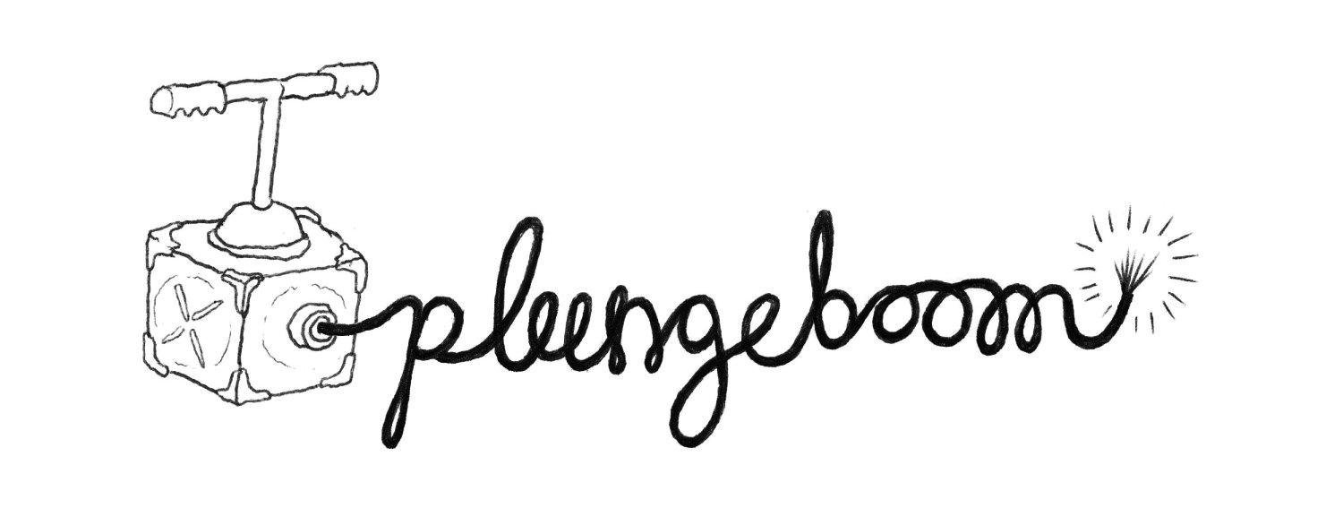
Risk Assessment for Let’s Grow
All teachers to complete and send to Plunge Boom before visit
Date of Actors Visits for Let’s Grow:

Teachers Present during interactive performance:

Location in School of Performance:

Teacher who is responsible/coordinating Let’s Grow programme:

Children have given/not given consent for photographs/film to be taken and used by Plunge Boom publically:

Comments if necessary_________________________________________

All teachers are required to check the babies and bottles before each unit deliver.
Risk | Likelihood | Response | Action Required | Complete
Small parts on characters become loose and a possible choking hazard | Medium | All ‘parts’ are as securely fastened as possible and checked before each performance/ unit delivery | Students to be supervised at all times with characters.
Bottles leaking | Low | Bottles checked before each performance/ unit delivery | Teachers provided with glue gun to reseal bottles.
Students put characters dummies and bottles in own mouth | Medium | Students reminded before every performance /unit delivery this is not suitable. | Teachers close supervision.
Staff leave the session, leaving Plunge Boom Staff supervising students | Low | All teachers reminded not to leave the session | If a teacher does leave a session, Plunge Boom staff will wait until their return. If there is 3 Plunge Boom staff, only one will leave to find teacher. No member of Plunge Boom staff will be left alone with a child/children

